**EXPT NO : 2 A python program to implement Simple linear DATE: 20.8.24 Regression using Least Square Method**

# AIM:

To write a python program to implement Simple linear regression using Least Square Method.

# PROCEDURE:

Implementing Simple linear regression using Least Square method using the headbrain dataset involve the following steps:

## Step 1: Import Necessary Libraries

First, import the libraries that are essential for data manipulation, visualization, and model building.

import pandas as pd

import matplotlib.pyplot as plt import numpy as np

## Step 2: Load the Iris Dataset

The HeadBrain dataset can be loaded.

data = pd.read_csv('/content/headbrain.csv')

## Step 3: Data Preprocessing

Ensure the data is clean and ready for modeling. Since the Iris dataset is clean, minimal preprocessing is needed.

x,y=np.array(list(data['Head Size(cm^3)'])),np.array(list(data['Brain Weight(grams)']))

print(x[:5],y[:5])

# OUTPUT :



## Step 4 :Compute the Least Squares Solution

Apply the least squares formula to find the regression coefficients.

def get_line(x,y):

x_m,y_m = np.mean(x), np.mean(y) print(x_m,y_m)

x_d,y_d=x-x_m,y-y_m

m = np.sum(x_d*y_d)/np.sum(x_d**2) c = y_m - (m*x_m)

print(m, c)

return lambda x : m*x+c lin=get_line(x,y)

# OUTPUT :



## Step 5 : Make Predictions

Use the model to make predictions based on the independent variable.

**def get_error(line_fuc, x, y):**

**y_m = np.mean(y)**

**y_pred = np.array([line_fuc(_) for _ in x]) ss_t = np.sum((y-y_m)**2)**

**ss_r = np.sum((y-y_pred)**2) return 1-(ss_r/ss_t)**

**get_error(lin, x, y)**

**from sklearn.linear_model import LinearRegression x = x.reshape((len(x),1))**

**reg=LinearRegression() reg=reg.fit(x, y)**

**print(reg.score(x, y))**

# OUTPUT :





## Step 6 :Visualize the Results

Plot the original data points and the fitted regression line.

x=np.linspace(np.min(x)-100,np.max(x)+100,1000) y=np.array([lin(x)for x in x])

plt.plot(x, y, color='red', label='Regression line') plt.scatter(x, y, color='green', label='Scatter plot') plt.xlabel('Head Size(cm^3)')

plt.ylabel('Brain Weight(grams)') plt.legend()

plt.show()

# OUTPUT :

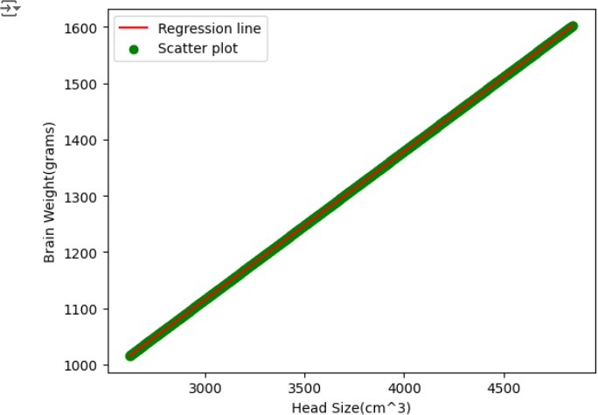

**RESULT:**

This step-by-step process will help us to implement least square regression models using the HeadBrain dataset and analyze their performance.